 | Day | More OT
 | 1 | Ps 8
 | 2 | Prov 1
 | 3 | Ps 1
 | 4 | Ps 33
 | 5 | Ps 119:1-8
 | 6 | Ps 119:9-16
 | 7 | Ps 63
 | 8 | Ps 119:17-24
 | 9 | Ps 101
 | 10 | Ps 23
 | 11 | Ps 30
 | 12 | Prov 27
 | 13 | Ps 41
 | 14 | Ps 119:25-32
 | 15 | Ps 119:33-40
 | 16 | Ps 119:41-48
 | 17 | Ps 119:49-56
 | 18 | Ps 119:57-64
 | 19 | Ps 119:65-72
 | 20 | Ps 119:73-80
 | 21 | Ps 88
 | 22 | Prov 22
 | 23 | Ps 113
 | 24 | Ps 119:81-88
 | 25 | Ps 119:89-96
 | 26 | Ps 119:97-104
 | 27 | Ps 105
 | 28 | Ps 119:105-112
 | 29 | Ps 29
 | 30 | Ps 119:113-120
 | 31 | Ps 119:121-128
 | Day | More OT
 | 32 | Ps 119:129-136
 | 33 | Ps 119:137-144
 | 34 | Ps 106
 | 35 | Ps 74
 | 36 | Ps 76
 | 37 | Ps 81
 | 38 | Ps 119:145-152
 | 39 | Ps 67
 | 40 | Ps 119:153-160
 | 41 | Ps 15
 | 42 | Ps 119:161-168
 | 43 | Ps 133
 | 44 | Ps 31
 | 45 | Ps 119:169-176
 | 46 | (open)
 | 47 | Ps 72
 | 48 | (open)
 | 49 | Ps 91
 | 50 | Ps 24
 | 51 | (open)
 | 52 | Ps 62
 | 53 | (open)
 | 54 | (open)
 | 55 | (open)
 | 56 | (open)
 | 57 | (open)
 | 58 | (open)
 | 59 | (open)
 | Day | More OT
 | 60 | (open)
 | 61 | Ps 61
 | 62 | (open)
 | 63 | Ps 46
 | 64 | (open)
 | 65 | (open)
 | 66 | Prov 26
 | 67 | (open)
 | 68 | (open)
 | 69 | (open)
 | 70 | Prov 20
 | 71 | Ps 35
 | 72 | Ps 69
 | 73 | (open)
 | 74 | Ps 78
 | 75 | (open)
 | 76 | (open)
 | 77 | Ps 65
 | 78 | Ps 114
 | 79 | Ps 136
 | 80 | (open)
 | 81 | (open)
 | 82 | (open)
 | 83 | (open)
 | 84 | (open)
 | 85 | (open)
 | 86 | (open)
 | 87 | Ps 107
 | 88 | Ps 22
 | 89 | (open)
 | 90 | Ps 109
 | Day | More OT
 | 91 | Ps 16
 | 92 | (open)
 | 93 | (open)
 | 94 | Prov 12
 | 95 | (open)
 | 96 | (open)
 | 97 | (open)
 | 98 | (open)
 | 99 | (open)
 | 100 | (open)
 | 101 | (open)
 | 102 | Ps 2
 | 103 | Ps 135
 | 104 | Ps 77
 | 105 | Ps 108
 | 106 | (open)
 | 107 | (open)
 | 108 | (open)
 | 109 | Prov 18
 | 110 | (open)
 | 111 | (open)
 | 112 | (open)
 | 113 | (open)
 | 114 | (open)
 | 115 | (open)
 | 116 | (open)
 | 117 | (open)
 | 118 | Ps 83
 | 119 | Prov 24
 | 120 | Ps 5
 | Day | More OT
 | 121 | Ps 32
 | 122 | (open)
 | 123 | (open)
 | 124 | (open)
 | 125 | Ps 44
 | 126 | Ps 47
 | 127 | Ps 25
 | 128 | Ps 14
 | 129 | Ps 94
 | 130 | Ps 75
 | 131 | Ps 123
 | 132 | Ps 117
 | 133 | (open)
 | 134 | Ps 115
 | 135 | Ps 59
 | 136 | Ps 56
 | 137 | Ps 52
 | 138 | Ps 54
 | 139 | Ps 57
 | 140 | Prov 5
 | 141 | (open)
 | 142 | (open)
 | 143 | Ps 89
 | 144 | Ps 26
 | 145 | Ps 60
 | 146 | Ps 51
 | 147 | Ps 3
 | 148 | Ps 7
 | 149 | (open)
 | 150 | Prov 30
 | 151 | Prov 29
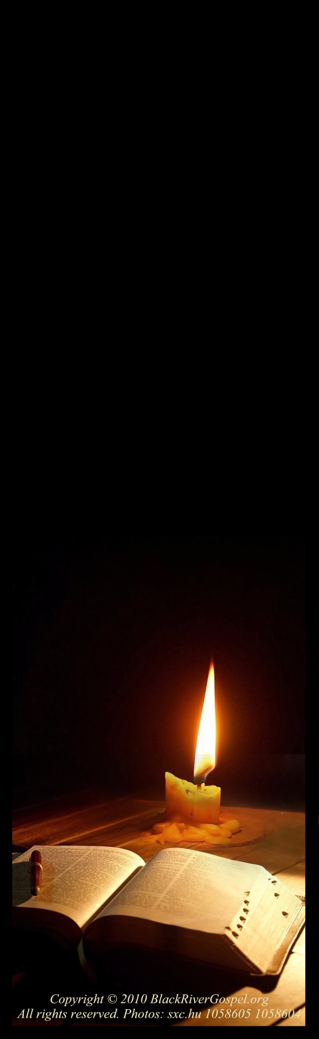
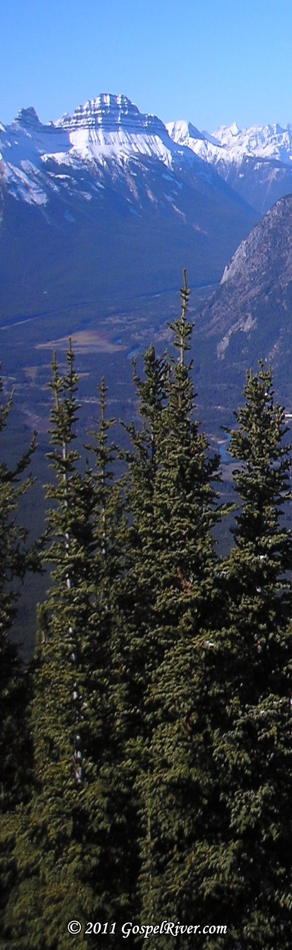
Reading Plan
Reading Plan
Reading Plan

Reading Plan
Reading Plan

 | Day | More OT
 | 152 | (open)
 | 153 | Ps 116
 | 154 | (open)
 | 155 | Prov 13
 | 156 | Ps 28
 | 157 | (open)
 | 158 | Ps 112
 | 159 | (open)
 | 160 | (open)
 | 161 | Prov 7
 | 162 | Ps 139
 | 163 | (open)
 | 164 | Prov 19
 | 165 | (open)
 | 166 | (open)
 | 167 | Prov 6
 | 168 | Ps 125
 | 169 | Ps 68
 | 170 | Ps 103
 | 171 | Ps 64
 | 172 | Ps 4
 | 173 | Ps 71
 | 174 | Ps 6
 | 175 | Ps 138
 | 176 | Prov 15
 | 177 | (open)
 | 178 | Ps 37
 | 179 | Ps 130
 | 180 | Prov 8
 | 181 | Ps 100
 | Day | More OT
 | 213 | (open)
 | 214 | (open)
 | 215 | (open)
 | 216 | (open)
 | 217 | (open)
 | 218 | (open)
 | 219 | (open)
 | 220 | (open)
 | 221 | (open)
 | 222 | Ps 134
 | 223 | (open)
 | 224 | (open)
 | 225 | (open)
 | 226 | (open)
 | 227 | (open)
 | 228 | (open)
 | 229 | (open)
 | 230 | Ps 73
 | 231 | (open)
 | 232 | Prov 11
 | 233 | (open)
 | 234 | Ps 66
 | 235 | (open)
 | 236 | Prov 14
 | 237 | (open)
 | 238 | Ps 129
 | 239 | (open)
 | 240 | Prov 25
 | 241 | Prov 28
 | 242 | (open)
 | 243 | Ps 147
 | Day | More OT
 | 244 | Ps 131
 | 245 | Ps 104
 | 246 | (open)
 | 247 | (open)
 | 248 | (open)
 | 249 | (open)
 | 250 | (open)
 | 251 | (open)
 | 252 | (open)
 | 253 | (open)
 | 254 | Ps 42
 | 255 | Ps 99
 | 256 | (open)
 | 257 | Prov 23
 | 258 | Ps 137
 | 259 | Ps 146
 | 260 | Ps 82
 | 261 | (open)
 | 262 | Ps 70
 | 263 | (open)
 | 264 | SofS 1
 | 265 | SofS 2
 | 266 | SofS 3
 | 267 | SofS 4
 | 268 | SofS 5
 | 269 | SofS 6
 | 270 | SofS 7
 | 271 | SofS 8
 | 272 | Ps 19
 | 273 | Ps 96
 | Day | More OT
 | 274 | Ps 36
 | 275 | Ps 53
 | 276 | Ps 148
 | 277 | (open)
 | 278 | (open)
 | 279 | Ps 118
 | 280 | Ruth 1
 | 281 | Ruth 2
 | 282 | Ruth 3
 | 283 | Ruth 4
 | 284 | Prov 16
 | 285 | (open)
 | 286 | Ps 18
 | 287 | (open)
 | 288 | Ps 21
 | 289 | Prov 17
 | 290 | Ps 93
 | 291 | Ps 49
 | 292 | Ps 55
 | 293 | (open)
 | 294 | (open)
 | 295 | (open)
 | 296 | Ps 122
 | 297 | Ps 80
 | 298 | Ps 27
 | 299 | Ps 84
 | 300 | Ps 128
 | 301 | Prov 21
 | 302 | Prov 4
 | 303 | Ps 124
 | 304 | Ps 12
Reading Plan
Reading Plan
Reading Plan

Reading Plan
Reading Plan
 | Day | More OT
 | 182 | Ps 141
 | 183 | (open)
 | 184 | Ps 132
 | 185 | (open)
 | 186 | (open)
 | 187 | Ps 145
 | 188 | Esther 1
 | 189 | Esther 2
 | 190 | Esther 3
 | 191 | Esther 4
 | 192 | Esther 5
 | 193 | Esther 6
 | 194 | Esther 7
 | 195 | Esther 8
 | 196 | Esther 9
 | 197 | Esther 10
 | 198 | (open)
 | 199 | (open)
 | 200 | Ps 50
 | 201 | (open)
 | 202 | (open)
 | 203 | (open)
 | 204 | (open)
 | 205 | (open)
 | 206 | Ps 8
 | 207 | (open)
 | 208 | (open)
 | 209 | (open)
 | 210 | Ps 20
 | 211 | (open)
 | 212 | Ps 79

Reading Plan
Reading Plan

 | Day | More OT
 | 305 | Ps 121
 | 306 | Ps 111
 | 307 | Ps 127
 | 308 | Prov 31
 | 309 | (open)
 | 310 | Ps 45
 | 311 | Ps 102
 | 312 | Ps 95
 | 313 | Ps 144
 | 314 | Ps 110
 | 315 | (open)
 | 316 | (open)
 | 317 | (open)
 | 318 | (open)
 | 319 | Ps 40
 | 320 | (open)
 | 321 | Prov 3
 | 322 | Ps 43
 | 323 | Ps 10
 | 324 | Prov 2
 | 325 | Ps 39
 | 326 | Ps 120
 | 327 | Ps 13
 | 328 | Ps 126
 | 329 | Ps 143
 | 330 | Ps 11
 | 331 | Ps 34
 | 332 | Ps 142
 | 333 | Prov 9
 | 334 | Prov 10
 | Day | More OT
 | 335 | Ps 90
 | 336 | (open)
 | 337 | Ps 140
 | 338 | Ps 17
 | 339 | Ps 92
 | 340 | (open)
 | 341 | Ps 86
 | 342 | Ps 85
 | 343 | Ps 149
 | 344 | (open)
 | 345 | Ps 97
 | 346 | Ps 38
 | 347 | Daniel 1
 | 348 | Daniel 2
 | 349 | Daniel 3
 | 350 | Daniel 4
 | 351 | Daniel 5
 | 352 | Daniel 6
 | 353 | Daniel 7
 | 354 | Daniel 8
 | 355 | Daniel 9
 | 356 | Daniel 10
 | 357 | Daniel 11
 | 358 | Daniel 12
 | 359 | Ps 58
 | 360 | Ps 48
 | 361 | (open)
 | 362 | Ps 98
 | 363 | Ps 9
 | 364 | Ps 87
 | 365 | Ps 150

